**CECS 343:   
Mythinati Game**

**Project Plan Document**

**Group A**

**Grayson Hill**

**Glizelle Marie Mapa**

**Rachel Pai**

# Document Revision History

|  |  |  |
| --- | --- | --- |
| **VERSION NUMBER** | **START DATE** | **END DATE** |
| 1 | Tuesday, February 18, 2020 | Tuesday, February 25, 2020 |
| 2 | Monday, May 4, 2020 | Tuesday, May 5, 2020 |
|  |  |  |
|  |  |  |

# 

# Table of Contents

Document Revision History 2

Table of Contents 3

1. Overview 5

2. Goals and Scope 5

2.1. Project Goals 5

2.2. Project Scope 7

2.2.1. Included 7

2.2.2. Excluded 7

3. Organization 7

3.1. Organizational Boundaries and Interfaces 8

3.1.1. Resource Owners 8

3.1.2. Receivers 8

3.1.3. Subcontractors 8

3.1.4. Suppliers 8

3.1.5. Cross Functions 8

3.1.6. Other Projects 8

3.2. Project Organization 9

3.2.1. Project Manager 9

3.2.2. Project-Internal Functions 9

3.2.3. Project Team 9

3.2.4. Steering Committee 10

4. Schedule and Budget 10

4.1. Work Breakdown Structure 10

4.2. Schedule and Milestones 11

4.2.1. Gantt Chart 12

4.2.2. Gantt Chart (Reality) 14

4.3. Budget 15

4.4. Development Process 16

4.5. Development Environment 16

4.6. Measurements Program 17

5. Risk Management 17

6. Sub-Contract Management 18

7. Communication and Reporting 18

8. Delivery Plan 19

8.1. Deliverables and Receivers 19

8.2. What was Delivered and Received 19

9. Quality Assurance 19

10. Configuration and Change Management 19

11. Security Aspects 20

12. Abbreviations and Definitions 20

13. References 20

# 

# Overview

* 1. Mythinati is a digitization of the *Illuminati* Board Game by Steve Jackson Games themed around myths and legends. The goal is to create a myth-themed game following the ruleset of *Illuminati* that can support 4-6 players in online multiplayer format. This will expand the potential market of *Illuminati* and pave the way for more board game digitizations. The project should be relatively low cost as it uses primarily free software, except for Photon which will be affordable on a per-user basis if more than 20 simultaneous players are using the game at one given time (and free for a low number of users).

# Goals and Scope

## Project Goals

|  |  |  |
| --- | --- | --- |
| **Project Goal** | **Priority** | **Comment/Description/Reference** |
| **Functional Goals:** |  |  |
| Game Rules System | 1 | *Illuminati* Rulebook, the general guidelines that allows players to understand gameplay mechanics for the game |
| Card/Hierarchy System | 1 | *Illuminati* Rulebook, the user’s ability to interact with cards and build power structures |
| Multiplayer System | 2 | User’s ability to join and play games of Mythinati with other users |
| Mythinati Character Selection | 2 | *Illuminati* Rulebook, all 8 *Illuminati* central cards converted into selectable characters. |
| Player Chat | 3 | Users ability to communicate both publicly and privately with other users in the game |
| **Business Goals:** |  |  |
| Raise Awareness of *Illuminati* | 2 | Raise awareness of the existence of the *Illuminati* board game, this should be a result of success in other areas of the project |
| Good CECS 343 Grade | 1 | Receive a good CECS 343 grade for our efforts; this should also be a result of success in other areas (i.e.. exams, readings, etc.) |
| **Technological Goals:** |  |  |
| Photon Implementation | 2 | Implementation of Photon Pun into the Unity game engine to facilitate multiplayer |
| **Quality Goals:** |  |  |
| Card Art | 3 | Custom art for the various in-game cards |
| UI/UX Design | 3 | Well-designed User Interface to streamline the user experience |
| **Constraints:** |  |  |
| Project Deadline | 1 | Project must be complete by the deadline (May 5, 2020) |
| Gameplayer support for more than 6 players | 5 | The traditional game is limited to 4 to 6 players; changing the game for more than 6 players would require additional software support and game rule accommodation. Additionally, it would result in a higher cost-per-game to support more concurrent users |

## 2.2. Project Scope

We will create a 4-6 player multiplayer card game placed on *Illuminati* themed around myth and legends. We will include the same rules as the original game, *Illuminati*, from Steve Jackson Games. It will include 8 different central cards, 83 different standard cards, and a couple special action cards.

### Included

* + - 1. 8 Different playable primary cards
      2. 83 Different standard cards
      3. Special Action Cards
      4. Multiplayer for 4-6 players
      5. Player UI and controls
      6. Full *Illuminati* Basic Ruleset
      7. User Manual (pdf format)

### Excluded

* + - 1. Mythinati will exclude support for operating systems that are not Windows 10 Operating System.
      2. Mythinati will not include an offline variant
      3. Mythinati will not include virtual tutorials
      4. Mythinati will not have multiple themes

# Organization

Our structure is like Extreme Programming organizational style, but with three people. The three people are developers that complement each other’s skill sets to create the game. The team is subject to the oversight of Professor Giacalone regarding project requirements and performance.

## Organizational Boundaries and Interfaces

The project is subject to the interest of external stakeholders - our users. The game is dependent on the novelty of the game Illuminati to help drive the success of the game’s release and future sales to elongate the run of the online game. While we are responsible for managing our own time and resources, all time and feature requirements and constraints are subject to Professor Giacalone. We do not have any customer or official subcontracted organizations.

### Resource Owners

* + - 1. We are not using any resources owned by someone else.

### Receivers

* + - 1. We will be delivering the product to the end-users, namely game players.

### Subcontractors

* + - 1. We are not using sub-contractors for this project.

### Suppliers

|  |  |  |
| --- | --- | --- |
| **Company: Contact** | **Deliverable** | **Comment** |
| Photon | Photon Pun | We are using this technology for the multiplayer feature of our game. |

### Cross Functions

There are no other departments involved in the making of this project. All team members will contribute in all aspects of the project, including documentation, software development, and project management.

### Other Projects

* + - 1. We are not dependent on any previous projects. We are also not a dependency for any future projects.

## Project Organization

We do not have other sub-projects within this project. Refer to section 3.1 for additional information.

### Project Manager

|  |  |
| --- | --- |
| **Role** | **Organization: Group A** |
| Project Manager | Grayson Hill |

### Project-Internal Functions

|  |  |  |
| --- | --- | --- |
| **Function** | **Organization: Group A** | **Comment** |
| Quality Assurance | Rachel Pai | QA is responsible for testing and making sure the project works as intended. |

### Project Team

|  |  |  |
| --- | --- | --- |
| **Organization: Group A** | **Availability** | **Comment** |
| Grayson Hill | 6 hours / week | Project manager; chief development officer |
| Glizelle Marie Mapa | 5 hours / week | Software developer; risk manager |
| Rachel Pai | 5 hours / week | Software developer; technical writer |

### Steering Committee

|  |  |  |
| --- | --- | --- |
| **Organization** | **Name** | **Comment** |
| CECS 343 | Professor Giacalone | The professor manages the general course of the project with executive decision power regarding features and direction of the project. |

# Schedule and Budget

## Work Breakdown Structure

1. Mythinati the game

1.1: Initiation Phase

1.1.1: Complete Vision Document

1.1.2: Establish Rules & Gameplay Functions from Original Board Game

1.1.3: Establish Priority-leveled Tasks to Complete Base Game Product

1.2: Development Phase

1.2.1: Complete Necessary Product Documents

1.2.2: Gather Assets & Design Gameplay Rules and Functions

1.3: Execution and Control

1.3.1: Begin Programming Gameplay Functions and Rules in Unity

1.3.2: Begin Implementing Photon Servers for Multiplayer Gameplay

1.3.3: Complete all High Priority Tasks and High-Medium Priority Tasks

1.4: Closeout

1.4.1: Release Base Mythinati Game with Rules and Essential Gameplay

Mechanics

## Schedule and Milestones

|  |  |  |  |
| --- | --- | --- | --- |
| Milestones | Description | Milestone Criteria | Planned Date |
| M0 | Start Project | Budget Release | <2020-02-06> |
|  | Section 1.1.1 from Work Breakdown Structure | Involved Stakeholders include Group A and Mr. Anthony Giacalone. | <2020-02-13> |
| M1 | Start Planning |  | <2020-02-17> |
|  | Section 1.2.1 from Work Breakdown Structure | Compile and Complete Vision Documents and Additional Documents for Mythinati Product | <2020-03-16> |
| M2 | Start Execution |  | <2020-03-23> |
|  | Section 1.2.2 from Work Breakdown Structure | Necessary Documents Reviewed and Approved, Resources for Unity and Photon Servers Committed | <2020-03-30> |
| M3 | Confirm Execution |  | <2020-04-06> |
|  | Sections 1.3.1 and 1.3.2 from Work Breakdown Structure | Design for Gameplay Functions and Rules approved. | <2020-04-10> |
| M4 | Start Introduction |  | <2020-04-21> |
|  | Section 1.3.3 from Work Breakdown Structure | Programming for Gameplay Functions and Rules finished. Currently documenting programs included in High Priority tasks. | <2020-05-04> |
| M5 | Release Product |  | <2020-05-11> |
|  | Section 1.4.1 from Work Breakdown Structure | Base Product tested and reviewed by involved stakeholders. | <2020-05-13> |
| M6 | Close Project |  | <2020-05-13> |

## Gantt Chart

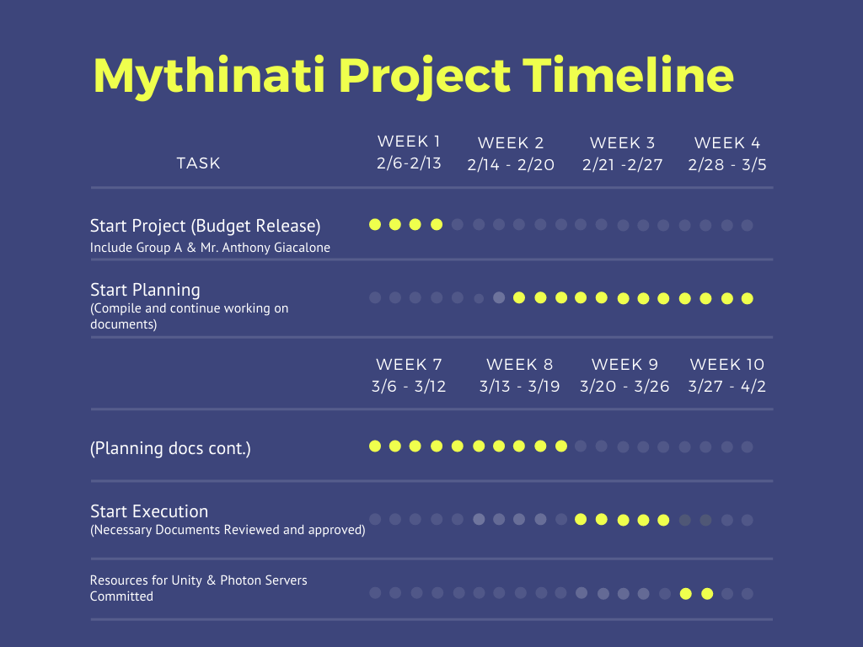

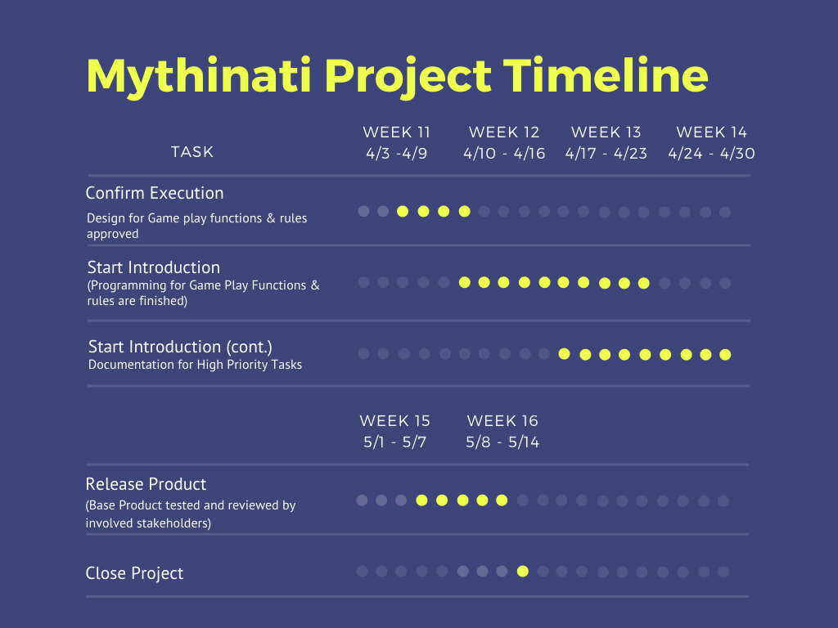

## 4.2.2. Gantt Chart (Reality)

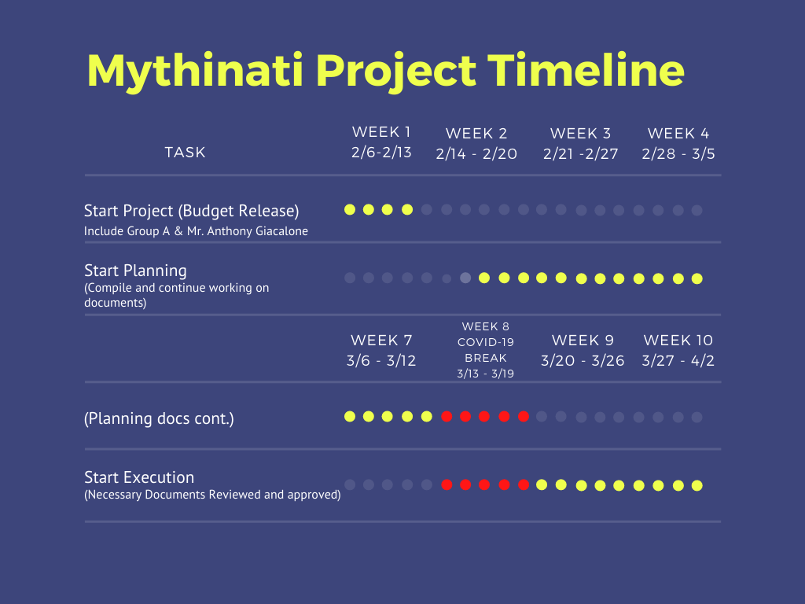

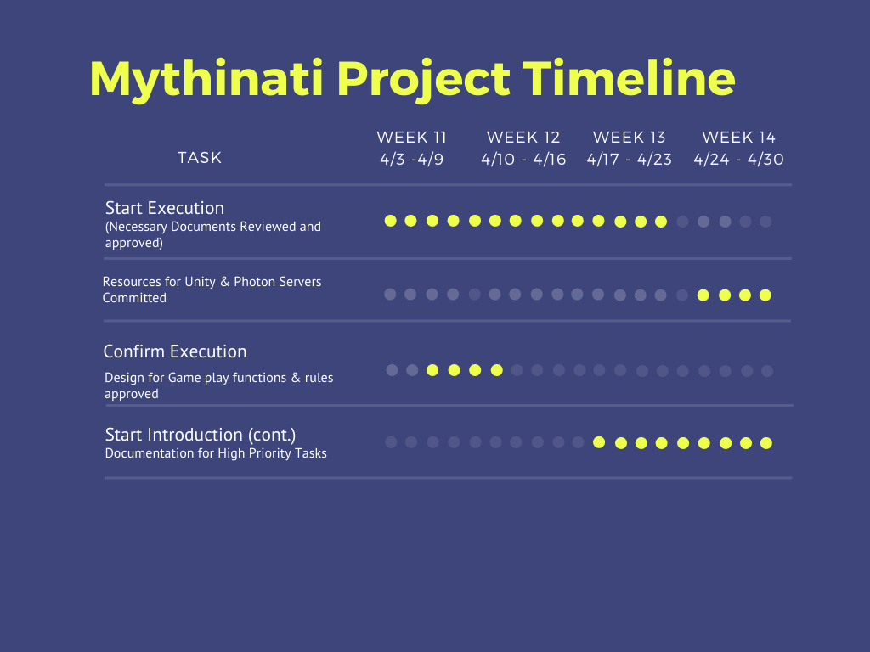

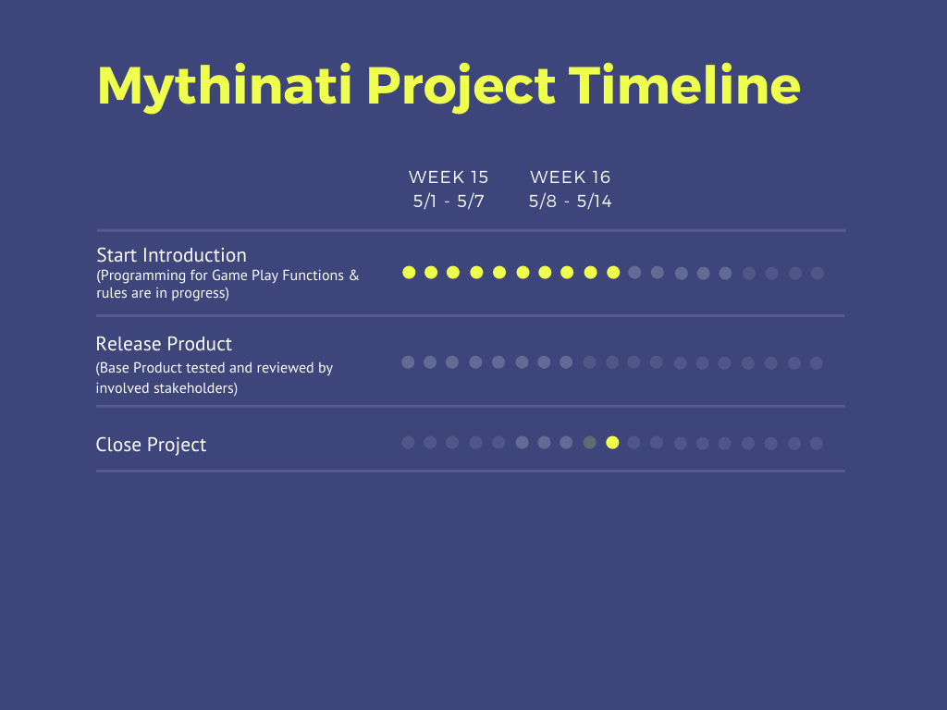

## Budget

|  |  |
| --- | --- |
| Category | Budget for Period |

|  |  |  |  |  |  |  |
| --- | --- | --- | --- | --- | --- | --- |
| (Internal) Human Resources | M0 - M1 | M1 - M2 | M2 - M3 | M3 - M4 | M4 - M5 | M5 - M6 |
| (External) Human Resources | 0 | 0 | 0 | 0 | 0 | 0 |
| Purchases | 0 | 0 | 0 | 0 | 0 | 0 |
| Equipment | 0 | 0 | 0 | 0 | 0 | 0 |
| Premises | 0 | 0 | 0 | 0 | 0 | 0 |
| Tools | 0 | 0 | 0 | 0 | 0 | 0 |
| Travel Costs | 0 | 0 | 0 | 0 | 0 | 0 |
| Training | 0 | 0 | 0 | 0 | 0 | 0 |
| Review Activities | 0 | 0 | 0 | 0 | 0 | 0 |
| Other | 0 | 0 | 0 | 0 | 0 | 0 |
| Total | 0 | 0 | 0 | 0 | 0 | 0 |
| **Total Accumulated** | **0** | **0** | **0** | **0** | **0** | **0** |

## Development Process

The current development process will follow a traditional top-down process that will allow developers and stakeholders involved to contribute to the original idea for Mythinati: The Game. This current process has been selected for the developers to understand how previous software engineers efficiently produced products for their clients. By applying the sequential stages of this top-down model to a semester project, the developers will proactively understand how the development process works in a practical workplace environment.

## Development Environment

|  |  |  |
| --- | --- | --- |
| Item | Applied For | Availability By |
| Methods |  |  |
| Use Case | Requirements capturing | M0 |
|  |  |  |
| Tools |  |  |
| Photon Servers | Multiplayer Function | M2 |
| Unity | Programming | M2 |
|  |  |  |
| Languages |  |  |
| C# | Programming | M2 |
|  |  |  |

## Measurements Program

|  |  |  |
| --- | --- | --- |
| **Type of Data** | **Purpose** | **Responsibility** |
| Amount of Changed Requirements | Record all changes made to required documents | Technical Writer |
| Number of Defects before M4 | Account for all possible Defects that can hinder Project’s Progress | Risk Manager |
| Performance Data | Record all past achievements and milestones completed in project | Project Manager |

# Risk Management

Estimated Risks

|  |  |  |
| --- | --- | --- |
| Risks | Probability | Impact |
| Equipment Failure | 50% | 2 |
| Late Delivery | 10% | 1 |
| Technology will not meet expectations | 15% | 2 |
| End users resist system | 10% | 2 |
| Changes in Requirements | 5% | 1 |
| Less reuse than planned | 30% | 3 |
| Poor comments in code | 7% | 4 |

All identified risks are assessed, prioritized, and documented by the Risk Manager, Project Manager, and Technical manager of Mythinati’s development team. In detail, the Risk Manager is responsible for assessing the current risks present in the project’s current progress, the Project Manager is responsible for prioritizing certain tasks to address the current risks, and the Technical Writer is responsible for recording past project risks and updating records on a monthly-basis. Further updates about present risks during project development will be communicated to all involved stakeholders by the Risk Manager.

# Sub-Contract Management

* 1. Not available. We are not sub-contracting to any organization.

# Communication and Reporting

|  |  |  |  |  |
| --- | --- | --- | --- | --- |
| **Type of Communication** | **Method/Tool** | **Frequency/Schedule** | **Information** | **Participants/ Responsibilities** |
| **Internal Communication:** | | | | |
| Project Meetings | In person / Discord | Bi-weekly | Project status, problems, changed formatting of documents | Group A |
| Sharing of project data | Google Docs / Github | When available | All project documentation and reports | Group A |
| **External Communication and Reporting:** | | | | |
| Sharing of project data and documentation | Github | Weekly | All project documentation and reports | Group A  Professor Giacalone |

# Delivery Plan

## Deliverables and Receivers

|  |  |  |  |
| --- | --- | --- | --- |
| **Identity** | **Deliverable** | **Planned Date** | **Receiver** |
| D1 | Product Documents | 03-30-2020 | Professor Giacalone |
| D2 | Base Game Product | 05-04-2020 | Professor Giacalone |
| D3 | Base Product Presentations | 05-11-2020 | Professor Giacalone |

## 8.2. What was Delivered and Received

|  |  |  |  |
| --- | --- | --- | --- |
| **Identity** | **Deliverable** | **Planned Date** | **Receiver** |
| D1 | Product Documents | 04-21-2020 | Professor Giacalone |
| D2 | Base Game Product | 05-04-2020 | Professor Giacalone |
| D3 | Base Product Presentations | 05-05-2020 | Professor Giacalone |

# Quality Assurance

* 1. We will utilize unit testing, debugging, and small-scale user testing. Unit testing and debugging will be done by the developers. The small-scale user testing will be given through a group of sample users to gather information about potential bugs and unintended functionality. After identifying the problems, we will use them as a guideline for items we need to fix or update for the next round of testing.
  2. Quality assurance’s role is to review the product consistently throughout the development of the product. Any defects or changes that need to be made will be communicated with the developers to improve the issue.

# Configuration and Change Management

* 1. The main point is to identify and control major software changes, making sure that any changes made are not so extreme as to break the project, and reporting to other members if there are any problems during the development of the project.
  2. The objective of this procedure is to try to minimize the negative impact of significant changes and to monitor, record, and communicate the different changes or concerns that arise.

# Security Aspects

* 1. This project is confidential towards other group teams in the class of CECS 343. We do not want to share information from our game with other teams.
  2. The project is not confidential towards users at delivery date.
  3. There is no need for a security check of project team members.
  4. Authorization of information distribution regarding the *Illuminati* rule book was approved by Professor Giacalone.
  5. Reporting of security incidents can be relayed to any Group A member.
     1. Grayson Hill
     2. Glizelle Marie Mapa
     3. Rachel Pai

# Abbreviations and Definitions

* 1. UI - User Interface
  2. UX - User Experience
  3. CECS - Computer Engineering and Computer Science
  4. Photon PUN - Implementation of the Photon multiplayer system designed to integrate with the Unity game engine

# References

* 1. <Doc 1> [Rulebook] 1981 *Illuminati* (boardgame), Jackson.